UServ Auto Insurance Product Case Study
Version 2 Copyright Business Rules Forum

Contents
Company Profile 2
Business Rules 2
Client Segmentation Business Rules 2
Eligibility Business Rules 3
Automobile Eligibility 3
Driver Eligibility 3
Eligibility Scoring 4
Pricing Business Rules 5
Auto Premiums 5
Auto Discounts 5
Driver Premiums 5
Market Segment Discounts 6
Scenarios 6
Grandfathered Rule Sets 6
Eligibility Within and Outside an Elite Client Relationship 9
Business Concepts (Fact) Model 10
Business Process Models 13
Process Vehicle Insurance Application 13
Process Policy Renewal 14
Process Policy 14
Score Policy 15

Company Profile
UServ Financial Services provides a full service portfolio of financial products, including:
- Insurance
  - Property and Casualty
  - Vehicle
    - Auto
    - Motorcycle
    - Boat
  - Life
  - Health
  - Business
- Banking
  - Demand Deposit
  - Savings
  - Money Market
  - Retirement
  - Loans
    - Mortgage
    - Credit Cards
    - Lines of Credit

UServ’s objective is to satisfy the complete financial services of its clients including their families, their businesses and their business colleagues. With this focus on complete relationship services, clients are rewarded for their loyalty as they deepen their relationship with UServ by increasing their financial portfolio.

UServ plays a balancing act between rewarding their best clients and managing the risk inherent in providing on-going service to clients whose portfolios are profitable, but violate the eligibility rules of individual products.

Business Rules
UServ’s business rules are an essential component for managing this risk. The business rules address eligibility, pricing and cancellation policies at both the individual product and portfolio level.

Client Segmentation Business Rules
This case study focuses on UServ’s vehicle insurance products, but differentiates the basic business rules from those that apply to preferred and elite clients.

A Preferred Client has a portfolio that includes at least three products. For example, a Preferred Client may have a portfolio that includes vehicle and life insurance policies and an Individual Retirement Account (IRA). A client is not a Preferred Client if their portfolio includes only three life insurance policies or four IRAs.
An Elite Client falls within UServ’s top 1% clients based on revenue. UServ currently has 2.5 million clients, so there are 25,000 Elite Clients.

Eligibility Business Rules
The base business rules are dependent on the type of vehicle being insured and the characteristics of the people covered by the policy.

Automobile Eligibility
Potential Theft Category
If the car is a convertible, then the car’s potential theft rating is high.
If the car’s price is greater than $45,000, then the car’s potential theft rating is high.
If the car model is on the list of “High Theft Probability Auto”, then the car’s potential theft rating is high.
If all of the following are true, then the car’s potential theft rating is moderate.
o car’s price is between $20,000 and $45,000,
o car model is not on the list of “High Theft Probability Auto”
If all of the following are true, then the car’s potential theft rating is low:
o car’s price is less than $20,000
o car model is not on the list of “High Theft Probability Auto”

The “High Theft Probability Auto” list is maintained by Risk Management and provided as input to the eligibility rating process.

Potential Occupant Injury Category
If the car has no airbags, then the car’s potential occupant injury rating is extremely high.
If the car is a convertible and has no roll bar, then the potential occupant injury is extremely high.
If the car only has driver’s air bag, then the car’s potential occupant injury rating is high.
If the car has driver’s and front passenger air bags, then the car’s potential occupant injury rating is moderate.
If the car has driver’s front passenger and side panel air bags, then the car’s potential occupant injury is low.

Auto Eligibility
If the Potential Occupant Injury Rating is extremely high, then the auto eligibility is “not eligible”.
If the Potential Occupant Injury Rating is high, then the auto eligibility is “provisional”.
If the Potential Theft Rating is high, then the auto eligibility is “provisional”.
If none of the following is true, then the auto eligibility is “eligible”.

Driver Eligibility
(applied to each driver covered by the application or policy)

Driver Age Category
If the driver is male and is under the age of 25, then young driver.
If the driver is female and is under the age of 20, then young driver.
If young driver and driver has training certification, then eligible driver.
If the driver is over the age of 70, then senior driver.
If senior driver and driver has training certification, then eligible driver.
If the following are not true, then eligible driver
o Young driver
o Senior driver
If driver has taken driver’s training from school then driver has training certification.
If driver has taken driver’s training from a licensed driver training company, then driver has training certification.
If driver had taken a senior citizen driver’s refresher course, then driver has training certification.

Driving Record Category
If the driver has been convicted of a DUI, then the driver qualifies as a High Risk Driver
If the number of accidents the applicant has been involved in is greater than 2, then the driver qualifies as a High Risk Driver.
If the driver has had more than 3 moving violations in the last two years, then the driver qualifies as a High Risk Driver.

Eligibility Scoring
A client’s eligibility for auto insurance is determined by a scoring system based on the risk ratings for various categories. The lower the score, the better the eligibility rating.
For each Auto: Auto Eligibility | Rating | Score
For each Auto: Auto Eligibility | Not Eligible | +100
For each Auto: Auto Eligibility | Provisional | +50
For each Auto: Auto Eligibility | Eligible | +0
For each Driver | Young Driver that is not an Eligible Driver | +30
For each Driver | Senior Driver that is not an Eligible Driver | +20
For each Driver | Eligible Driver | +0
For each Driver | High Risk Driver | +100
Client Segment | Preferred | -50
Client Segment | Elite | -120

If eligibility score is less than 100, then client is eligible for insurance
If eligibility score is between 100 and 250 inclusive, then the client’s application/policy renewal must be reviewed by underwriting manager who will determine whether the client is eligible for auto insurance.
If eligibility score is greater than 250, the client is not eligible for auto insurance.
If a long term client, the client is always eligible for auto insurance, as every person and car directly covered by a long term client’s auto policy.
A long term client has maintained a UServ portfolio for 15 years.

Pricing Business Rules
If the client is eligible for auto insurance, then the annual premium must be determined.

Auto Premiums
For each car on the policy:
If compact car, then base premium is $250.
If sedan, then base premium is $400.
If luxury car, then base premium is $500.
If car is new, then increase premium by $400.
If the model year is the same as the current year, then new car.
If the model year is the same as next year, then the car is new.
If car is less than 5 years old, then increase premium by $300.
If car is between 5 and 10 years old, then increase premium by $250.
For each uninsured motorist coverage included, increase premium by $300
For each medical coverage included, increase premium by $600.
If Potential Occupant Injury is Extremely High, then increase premium by $1,000.
If Potential Occupant Injury is High, then increase premium by $500.
If Potential Theft is High, then increase premium by $500.

Auto Discounts
If the car has only Driver airbags then lower the premium by 12 %.
If the car has Driver and Passenger airbags then lower the premium by 15 %.
If the car has Driver, Passenger and Side airbags then lower the premium by 18 %.
If the car is equipped with an alarm system, then lower the premium by 10%.

Driver Premiums
For each driver on the policy:
If young driver and married and located in CA, NY or VA, then increase premium by $700.
If young driver and single and located in CA, NY or VA, then increase premium by $720.
If young driver and married and not located in CA, NY or VA, then increase premium by $300.
If young driver and single and not located in CA, NY or VA, then increase premium by $300.
If senior driver and located in CA, NY or VA, then increase premium by $500.
If senior driver and not located in CA, NY or VA, then increase premium by $200.
Driver is a Typical Driver is all of the following are true:
o Not a Young Driver
o Not a Senior Driver
If a Typical Driver, then increase premium by $0.
If a High Risk Driver, then increase premium by $1,000.
Raise the premium by $ 150 per accident

Market Segment Discounts
These discounts are applied after all the individual car and driver premiums with discounts have been calculated. Total those premiums and then apply the market segment discounts.
If a preferred client, lower the premium by $250.
If an elite client, then lower the premium by $500.

Scenarios

Grandfathered Rule Sets
The purpose of this scenario, besides exercising the auto insurance eligibility and pricing business rules, is to establish business rules for determining preferred clients, apply them and then change the business rules to be more stringent. The original set of rules continues to apply to clients who qualified as premium clients under those rules. The new ruleset applies to new clients.

Preferred Client Business Rule V1

A Preferred Client has a portfolio that includes at least three products families. For example, a Preferred Client may have a portfolio that includes vehicle and life insurance policies and an Individual Retirement Account (IRA). A client is not a Preferred Client if their portfolio includes only three vehicle insurance policies or four IRAs.

Sara Klaus is a new customer establishing a portfolio of financial services:

o Checking Account
o IRA
o Property Insurance for her house
o Auto Insurance

She qualifies for a Preferred Client because she is establishing accounts and policies in more than three product families.

Auto profiles:
Car 1 | 2005 Honda Odyssey
Car 1 | Full Airbags
Car 1 | Alarm System
Car 1 | Price $39,000
Car 1 | Type: Luxury
Car 1 | Not on “High Theft Probability List”
Car 2 | 2002 Toyota Camry
Car 2 | Driver and Passenger Airbags
Car 2 | Price: $12,000
Car 2 | Type: Compact
Car 2 | Not on “High Theft Probability List”

Driver profiles:
Sara | Female
Sara | 38 years old
Sara | Single
Sara | Lives in Arizona
Sara | No Accidents
Sara | 1 Moving Violation
Sara | No DUIs
Spenser | Sara’s Son
Spenser | Male
Spenser | 17 years old
Spenser | Single
Spenser | Lives in Arizona
Spenser | No Accidents
Spenser | No Moving Violations
Spenser | No DUIs
Spenser | Has a Driver’s Training Certificate from school
Spenser | Has a Good Student Certificate

Options for each car: Uninsured Motorist, Medical Coverage

Premium Amount:
Preferred Client: Yes

Preferred Client Business Rule V2

Four months after Sara becomes a client, management wants to reward longevity as well as depth of a client’s portfolio. They have decided to change the Preferred Client eligibility rules to include a measure of longevity.

A Preferred Client has a portfolio that includes an average of three products families over the prior rolling 12 month period. The configuration of the portfolio families can change over the period, so long as the average is three product families. New clients must maintain this average for a year before they are eligible.

To ensure that the existing preferred clients are not upset over the change in these eligibility rules, they will continue to maintain their preferred client status until their portfolio configuration falls below the 3 family limit.

In this scenario, a new client with the exact same profile as Sara does not qualify for the preferred customer. Sara is re-rated at her six month anniversary and continues to qualify as a preferred client.

Auto profiles:
Car 1 | 2005 Honda Odyssey
Car 1 | Full Airbags
Car 1 | Alarm System
Car 1 | Price $39,000
Car 1 | Type: Luxury
Car 1 | Not on “High Theft Probability List”
Car 2 | 2002 Toyota Camry
Car 2 | Driver and Passenger Airbags
Car 2 | Price: $12,000
Car 2 | Type: Compact
Car 2 | Not on “High Theft Probability List”

Driver Profiles:
Mark Houston | Male
Mark Houston | 38 years old
Mark Houston | Single
Mark Houston | Lives in Arizona
Mark Houston | No Accidents
Mark Houston | 1 Moving Violation
Mark Houston | No DUIs
Angie | Mark’s Daughter
Angie | Female
Angie | 17 years old
Angie | Single
Angie | Lives in Arizona
Angie | No Accidents
Angie | No Moving Violations
Angie | No DUIs
Angie | Has a Driver’s Training Certificate from school
Angie | Has a Good Student Certificate

Options: Uninsured Motorist, Medical Coverage

Premium Amount:
Preferred Client: No

Re-rate Sara, everything is the same except the cars are a year older

Premium Amount:
Preferred Client: Yes

Eligibility Within and Outside an Elite Client Relationship
This scenario exercise the business rules related to cars and drivers that are not eligible on their own, but are when they are part of the portfolio owned by an Elite Client. When that person tries to establish their own portfolio, they are scored based on their own merit independent of their merit.

Ray Meno is a well known TV personality who has one of the largest car collections (137) that are covered by UServ’s auto insurance policy. Each member of his family (himself, his wife and 4 children) is covered by a million dollar life insurance policy. His UServ investment advisor manages his portfolio of real estate and financial investments.

Ray is UServ’s highest revenue generating Elite client for the last 18 years.

Shane Meno is Ray’s 21 year old son who has a problematic driving record. He drives one of his father’s classic cars.

Shane | Male
Shane | 21 years old
Shane | Single
Shane | Lives in California
Shane | 2 Accidents
Shane | 3 Moving Violations
Shane | No DUIs
Shane | Has a Driver’s Training Certificate from school
Shane’s Car | 1965 VW Bug
Shane’s Car | No Airbags
Shane’s Car | Price: $1,500
Shane’s Car | Type: Compact
Shane’s Car | On “High Theft Probability List”
Shane’s Car | Convertible
Shane’s Car | No Rollbar

Eligibility Score:
Premium for Shane:
Premium for Shane’s Car:
Applicable Discounts:

Shane marries and applies for an auto insurance policy for himself and his wife. He is no longer directly involved in his father’s portfolio.

Re-rate Shane’s application and determine whether he is eligible for auto insurance with UServ. He has installed a rollbar in his VW.

Business Concepts (Fact) Model
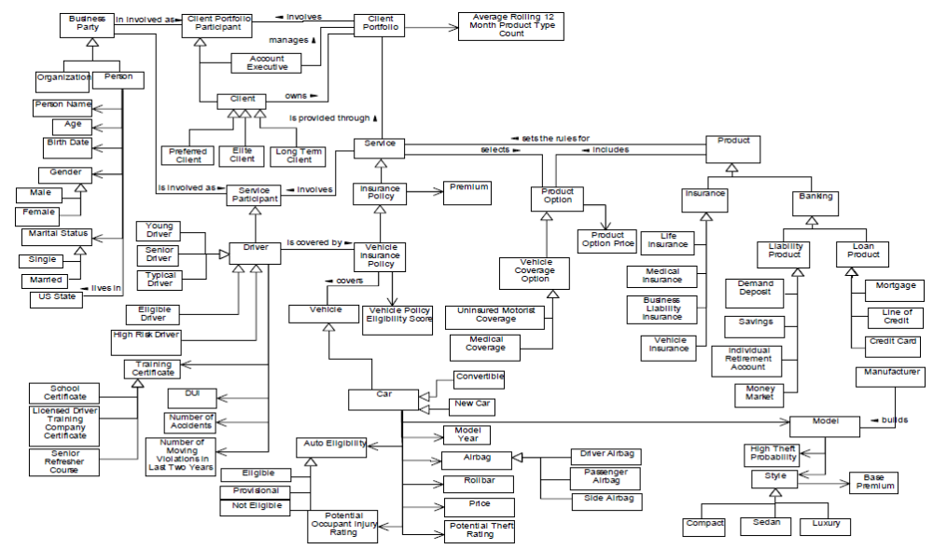

Business Concepts Model Key

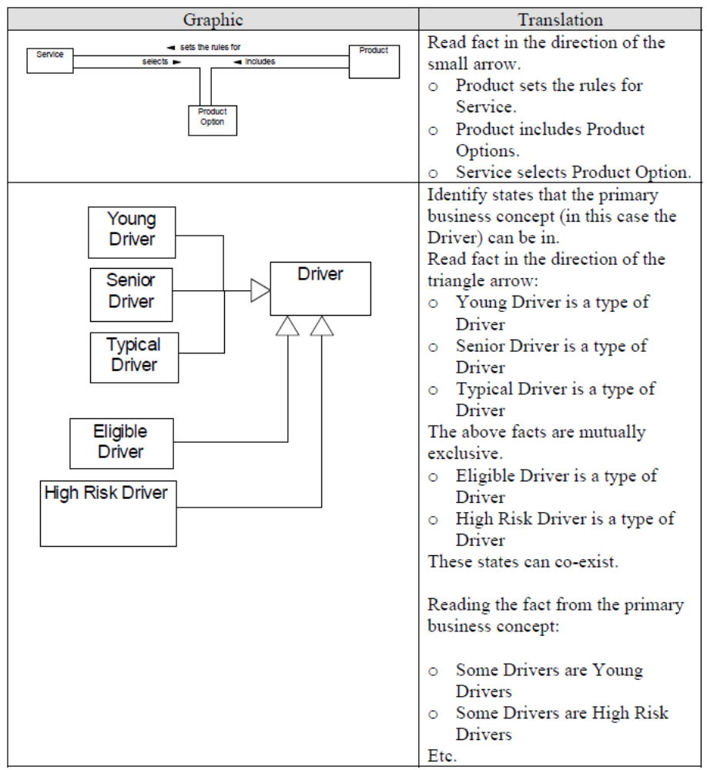

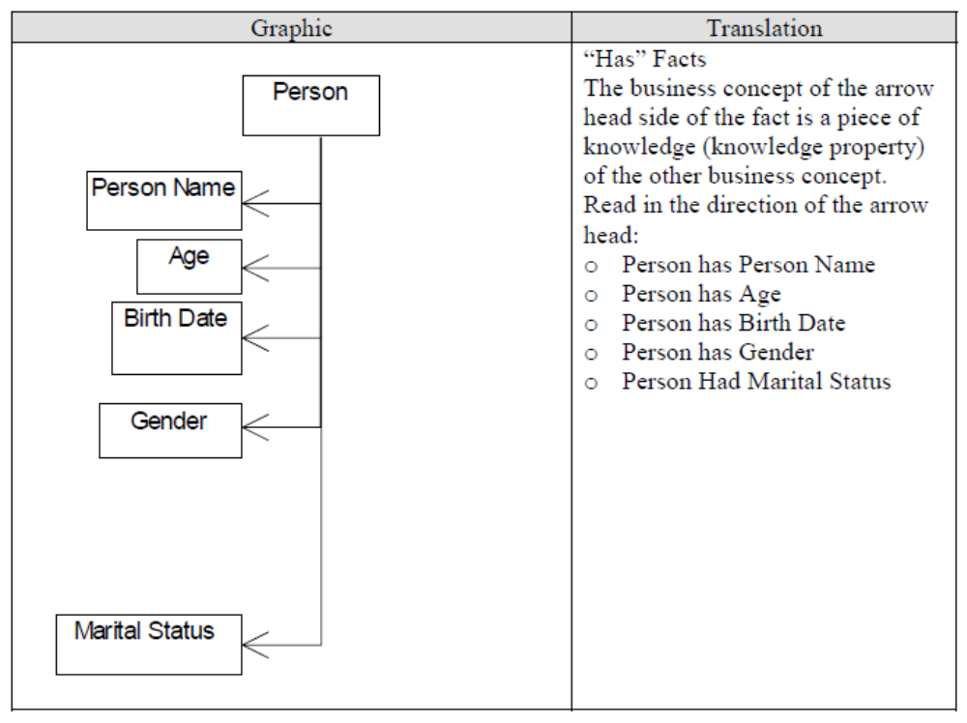

Facts are unconstrained. For example, the default statement for Service selects Product Option is A Service may select some Product Options. Business rules must be stated to constrain the fact, such as:
o Every Service must select at least one Product Option. “At least” translates to one or more.
o Every Service must be governed by exactly one Product. “Exactly one” translates to one and only one.

The business rules that constrain the facts are not provided in this case study.

The fact model is not intended to dictate the application’s object class model or database design. It represents the knowledge that must be available to support the business rules. The developer is free to choose how to represent this knowledge in the solution.

The solution does not need to determine whether the Client is an Elite Client. Assume that this information is provided to the application.

The solution does not need to calculate the rolling 12 month average product count. Assume that this information is provided to the application.

Business Process Models
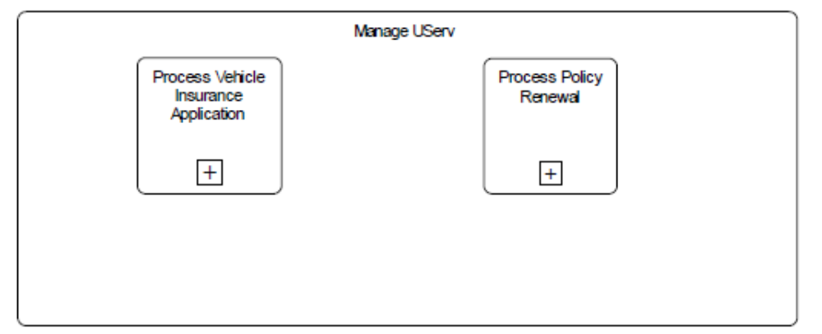

Process Vehicle Insurance Application
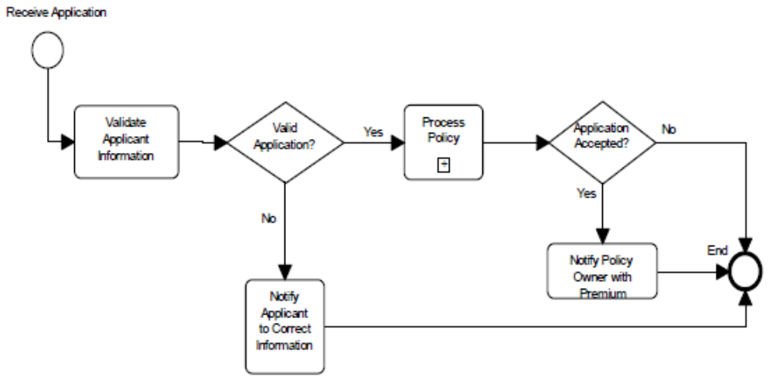

Process Policy Renewal
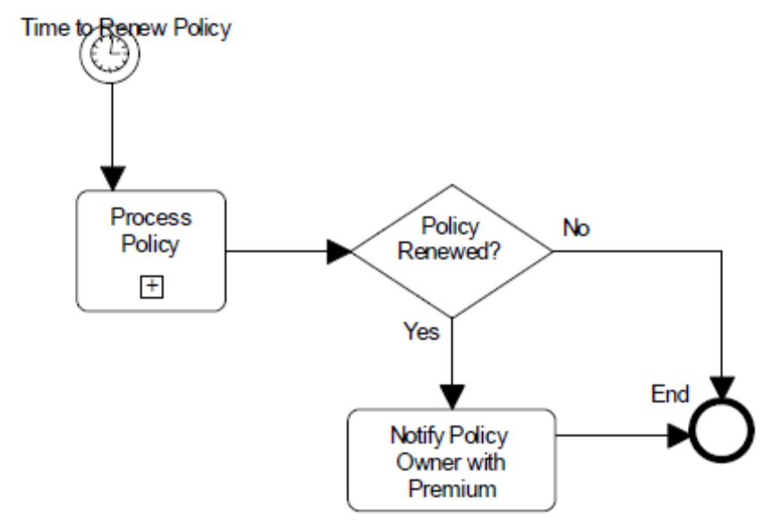

Process Policy
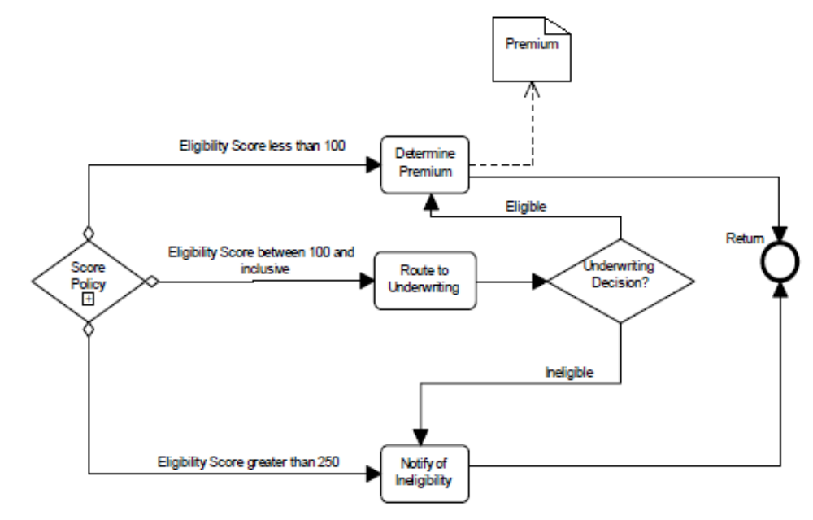

Score Policy
